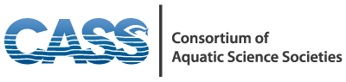

MEMORANDUM OF UNDERSTANDING

Between

American Fisheries Society (AFS)
Association for the Sciences of Limnology and Oceanography (ASLO)
Coastal and Estuarine Research Federation (CERF)
Freshwater Mollusk Conservation Society (FMCS)
International Association for Great Lakes Research (IAGLR)
North American Lake Management Society (NALMS)
Phycological Society of America (PSA)
Society for Freshwater Science (SFS)
Society of Wetland Scientists (SWS)

To form a Consortium of Aquatic Science Societies (CASS)

RECOGNIZING the importance of all aquatic and wetland ecosystems, spanning from headwaters to oceans, as significant components of the World’s ecosphere;

NOTING that the health of these freshwater, estuarine, and marine ecosystems is threatened globally by a wide variety of anthropogenic activities;

NOTING that these aquatic ecosystems are critical for the planet’s sustainability, and are an important economic resource for many nations in sectors such as aquaculture, fisheries, and tourism;

AWARE OF shared global interests, objectives, and leadership of AFS, ASLO, CERF, FMCS, IAGLR, NALMS, PSA, SFS, SWS and other organizations in promoting, coordinating, and sharing scientific expertise and knowledge of these global aquatic ecosystems; and

FURTHER NOTING the common interests of the AFS, ASLO, CERF, FMCS, IAGLR, NALMS, PSA, SFS, and SWS, and other organizations in expanding the international scope, membership, and influence of their respective organizations.

AFS, ASLO, CERF, FMCS, IAGLR, NALMS, PSA, SFS, and SWS AGREE to promote international aquatic ecosystem scientific study, education, and outreach via the creation of a Consortium of Aquatic Science Societies (CASS), and cooperation and action between the parties to this MOU. The parties specifically agree to the following:

- To jointly promote scientific research on aquatic ecosystems, from headwaters to the oceans, to better understand the hydrology, ecology, biogeochemistry, ecosystem services, and economic values of these natural resources.

- To promote understanding of the importance of these aquatic and wetland ecosystems in the face of a changing climate, and to share that knowledge with decision-makers considering the effects of this changing climate.

- To jointly organize and host, with additional partners where appropriate, regional or other small-scale workshops on aquatic ecosystem research, policy, and management issues in association with the respective Annual Meetings, Chapter, Affiliate, Commission Meetings, and Congresses of the member societies.

- To leverage our collective scientific knowledge of aquatic ecosystems and their watersheds to help inform environmental policy decisions.

- To develop joint proposals for funding, when possible, to advance the shared objectives of the member organizations.

- To share exhibit or booth space at select events of interest to multiple CASS members.

- To promote awareness of CASS member organizations among their respective memberships through regular publication of information items noting conferences, publications, and activities in the respective publications and web sites of the organizations.

- To develop and host a web portal among the CASS member organizations to facilitate sharing of information and outreach to external users of scientific information on aquatic and wetland issues.

- To encourage submission of professional papers on aquatic ecology in the CASS member organizations’ journals and other publications.

- To promote expanded participation of each organizations’ members, Chapters, and National Committees through membership and attendance at each other’s symposia or workshops and annual and regional meetings.

- To seek opportunities for sharing of expertise and professional standards among CASS members, and training of aquatic scientists, particularly in developing countries.

- To promote active participation in scientific meetings and international memberships in all CASS organizations, particularly among scientists from developing countries.

- To jointly promote global awareness of the wide range of important functions
and values carried out by aquatic ecosystems.

- To share governance, meeting and other best practices and lessons learned to promote better efficiency and effectiveness of the individual organizations.

- This MOU may be amended from time to time, by written consent of all parties hereto, to (among other things) include other organizations joining CASS.

- Presidents and organizational representatives will communicate regularly (usually monthly conference calls) to conduct CASS business, including the discussion and planning of CASS-sponsored events.

- All parties must diligently and conscientiously attempt to make decisions by consensus with full and careful consideration of minority views. When a consensus cannot be achieved, a single vote/member organization shall be taken by either the President or a designated CASS representative of each member organization.

- Only organizations involved in a CASS-sponsored event will be expected to contribute financially toward the expenses incurred for said event.

- Additional organizations will be considered for CASS membership by submitting a written letter of interest to the CASS members, participating in a monthly CASS member telephone call to describe their organization’s interests related to aquatic sciences, and then formalizing their intent in a letter to CASS. A membership decision will be made by the CASS members during a regular monthly phone call and then conveyed to the interested organization via letter.

- No party to this MOU shall have any legal or financial obligations to CASS or to any other party to this MOU, unless agreed to by separate, written agreement and signed by the relevant party or parties.

- This MOU shall become effective upon the signature of all parties hereto and may be renewed annually at the discretion of all parties hereto.

- Any party to this MOU may withdraw from CASS upon two (2) weeks prior written notice.

Signed on behalf of their respective organizations.

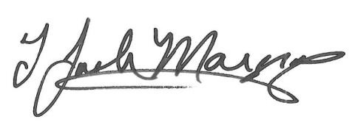 8/3/2017
_______________________________________ __________
Joseph Margraf Date
President, AFS

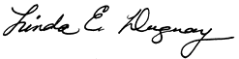 8/1/2017
_______________________________________ __________
Linda Duguay Date
President, ASLO

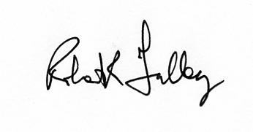 8/4/2017
_____________________________________
Robert R. Twilley Date
President, CERF

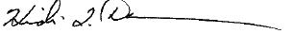 8/7/2017
______________________________________ __________
Heidi Dunn Date
President, FMCS

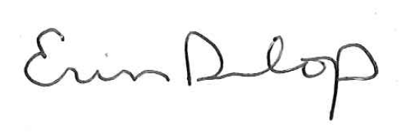 8/1/2017
_____________________________________ _________
Erin Dunlop
President, IAGLR Date

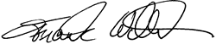 8/4/2017
______________________________________ _________
Frank Wilhelm Date
President, NALMS

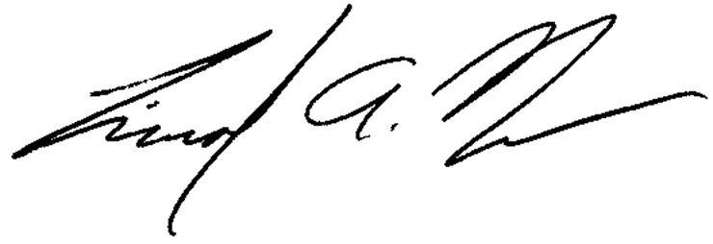 8/7/2017
_____________________________________ __________
Tim Nelson Date
President, PSA

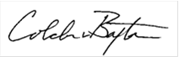 8/2/2017
_______________________________________ __________
Colden Baxter Date
President, SFS

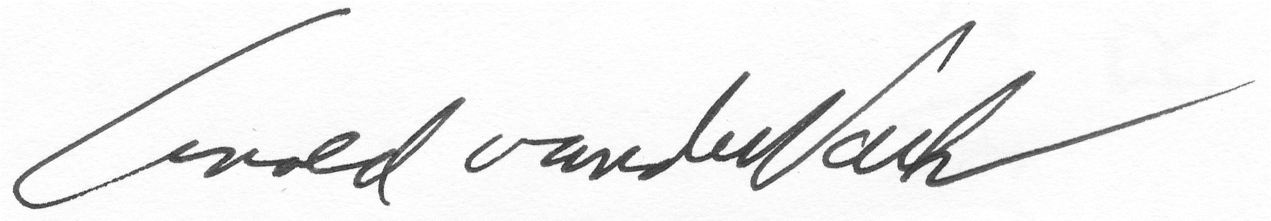 8/2/2017
_______________________________________ __________
Arnold van der Valk Date
President, SWS

